East West University

Project Report

Semester: Summer-2020

Course Code: CSE411

Section: 02

Group: 05

Date of Submission: September 21, 2020

Submitted By

Name: Md. Roky Ahmed

ID: 2017-1-60-150

Name: **Sazzad Rahman Sagor**

ID: **2016-2-65-031**

Submitted To

Course Instructor: MD. Mohsin Uddin

Lecturer, Department Of CSE, EWU

**Local Bus Route Finder**

**Project introduction:**

The Objective of our project is to solve the problem of local transportation finder. As an example, there are hundreds of busses in Dhaka city and rest of the Country each bus goes to several routes around the city. A person who lives in a part of the city he/she might not be aware of the other route or roads of the city. He/she needs to use local transportation but they are not aware which bus goes to which route. At that time our system comes in work. They simply can search by our system which bus goes to which routes by our system. Simply he/she can enter their location and enter the destination and system will tell them which bus goes to their desired destination with approximate time and fare with the shortest bus route available. By this implementation the hassle of a person will be reduced to some extent. So, we can call it route solution system.

**Project motivation:**

As we live in city, it is also a problem to find the available transportation for our desired routes. Because one do not go to the different routes everyday so it is very common to not know the routes bus name. And today’s modern time people find it very awkward to ask which bus goes to what place. So that motivated us to build a system that makes it easier to find the names of the bus. Also, it makes us knowledge about the city. As people comes outside of the city and ask us about the routes as a city people it is awkward by not to know the place/routes/bus names. That’s also inspires us to build the system. Mostly it is a problem solve system so it is helpful to people that’s also a reason.

**Project Challenges:**

1**.** The first challenge of this project is to gather the information of bus routes and names because we are in a lockdown state and it is almost impossible to go each place for bus routes and names and there are also no verified websites to gather the information. so, we have to gather the information from BRTA which is also a challenging task.

2. Implementation of the technologies is an also a challenge for this project as both of us are newbie to this web languages. So, it will be a tough job for us to finish the project.

3. Time management is also a factor for this project. As we have less time than other semesters.

4. Group work also can be hampered due to recent situations. Which also can affect to the final project.

5. Project implementation will also going to be challenging as we have lack of resources.

**Requirement Specification**

**Non-Functional Requirements:**

Security requirement: The system should be secured. As there is log in feature where user data/password will be stored so it is important

Usability requirement: The system should be easy to use by the users, As we want more people to use the system so usability should be easy.

Reliability requirement: The system shouldn't crush. It should be working fine for all the user who search for the service.

Recoverability requirement: A recoverable system. Where if a registered user forgot his/her log in info then they can recover it.

Availability requirement: The system should be available always. As it a city service so the system should run always.

Dependability requirement: The users are dependable to the system so the system should dependable to accurate data.

Efficiency requirement: The system should be efficient to the mark. And give output in less time.

Ethical requirement: The admin should not see user sensitive data.

**Functional Requirements:**

User:

1. User able to login to system.

2. User can also enter as guest user.

3. User able to search in system for their desired information (bus or route) info.

4. User can share the bus or root details with other people.

5. User will be able to see the approx. fare of some common routes, bus names, number of busses available.

6.bus details.

Admin:

1. Admin will be able to login to system.

2. Admin Able to create user login for User.

3. Admin Can update the records of the system as such new bus or update route details.

4. Admin should not see the user password as ethical issue.

**System Block Diagram**

**System**

**Guest User UuseUsUser**

**Registered user**

**Search by Location**

**Add Bus/Route info**

**Bus Name**

**User Feedback**

**Approximate**

**fare/time**

**Admin Log In**

**Admin Panel**

**Maintenance**

**User Feedback**

**Update/Modify**

**Technologies used:**

For developing the system. we are going to use

*HTML

*CSS/BOOTSTRAP

*jquery

*MySQL

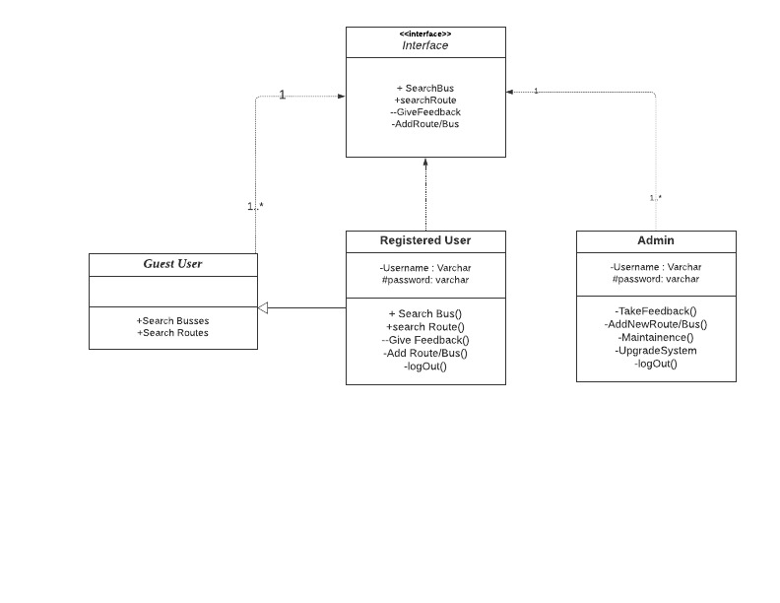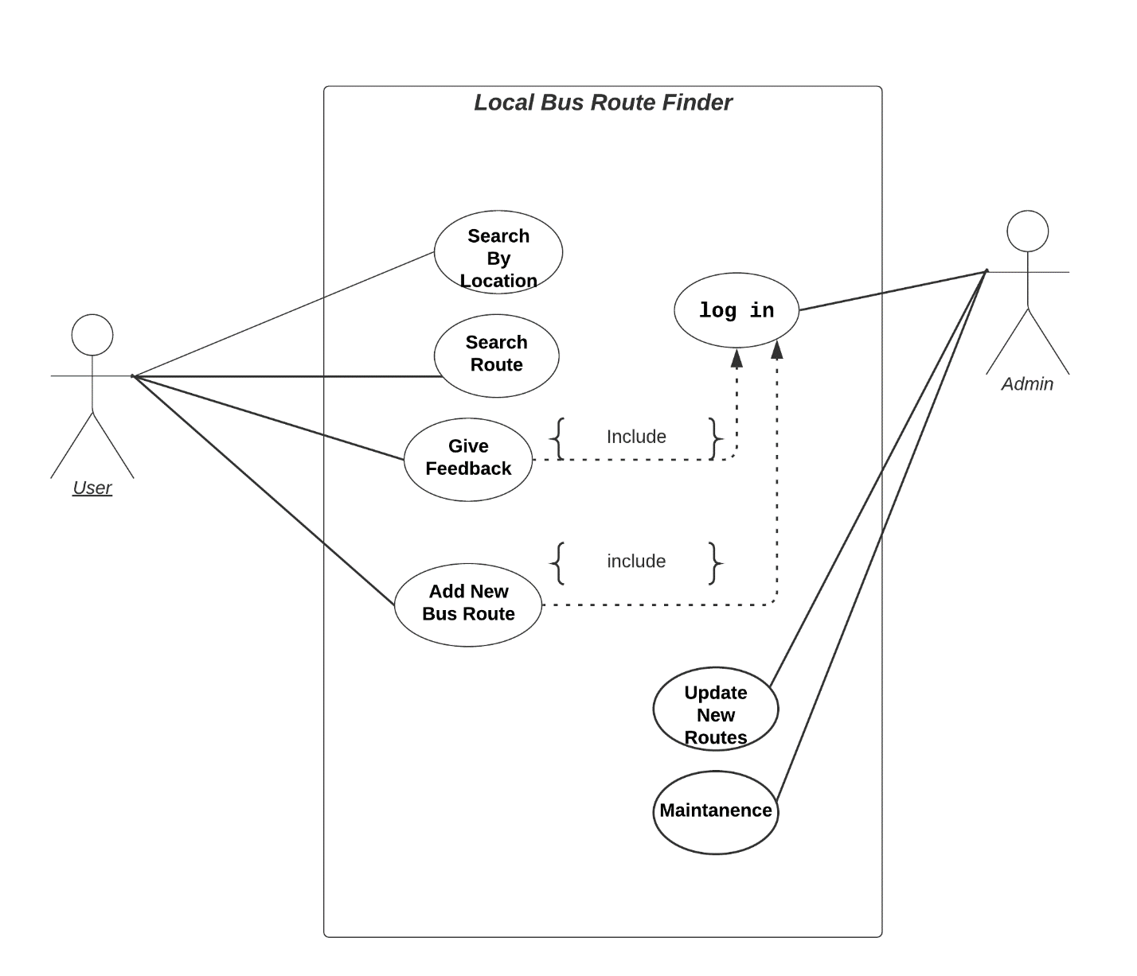Class Diagram

Use Case Diagram

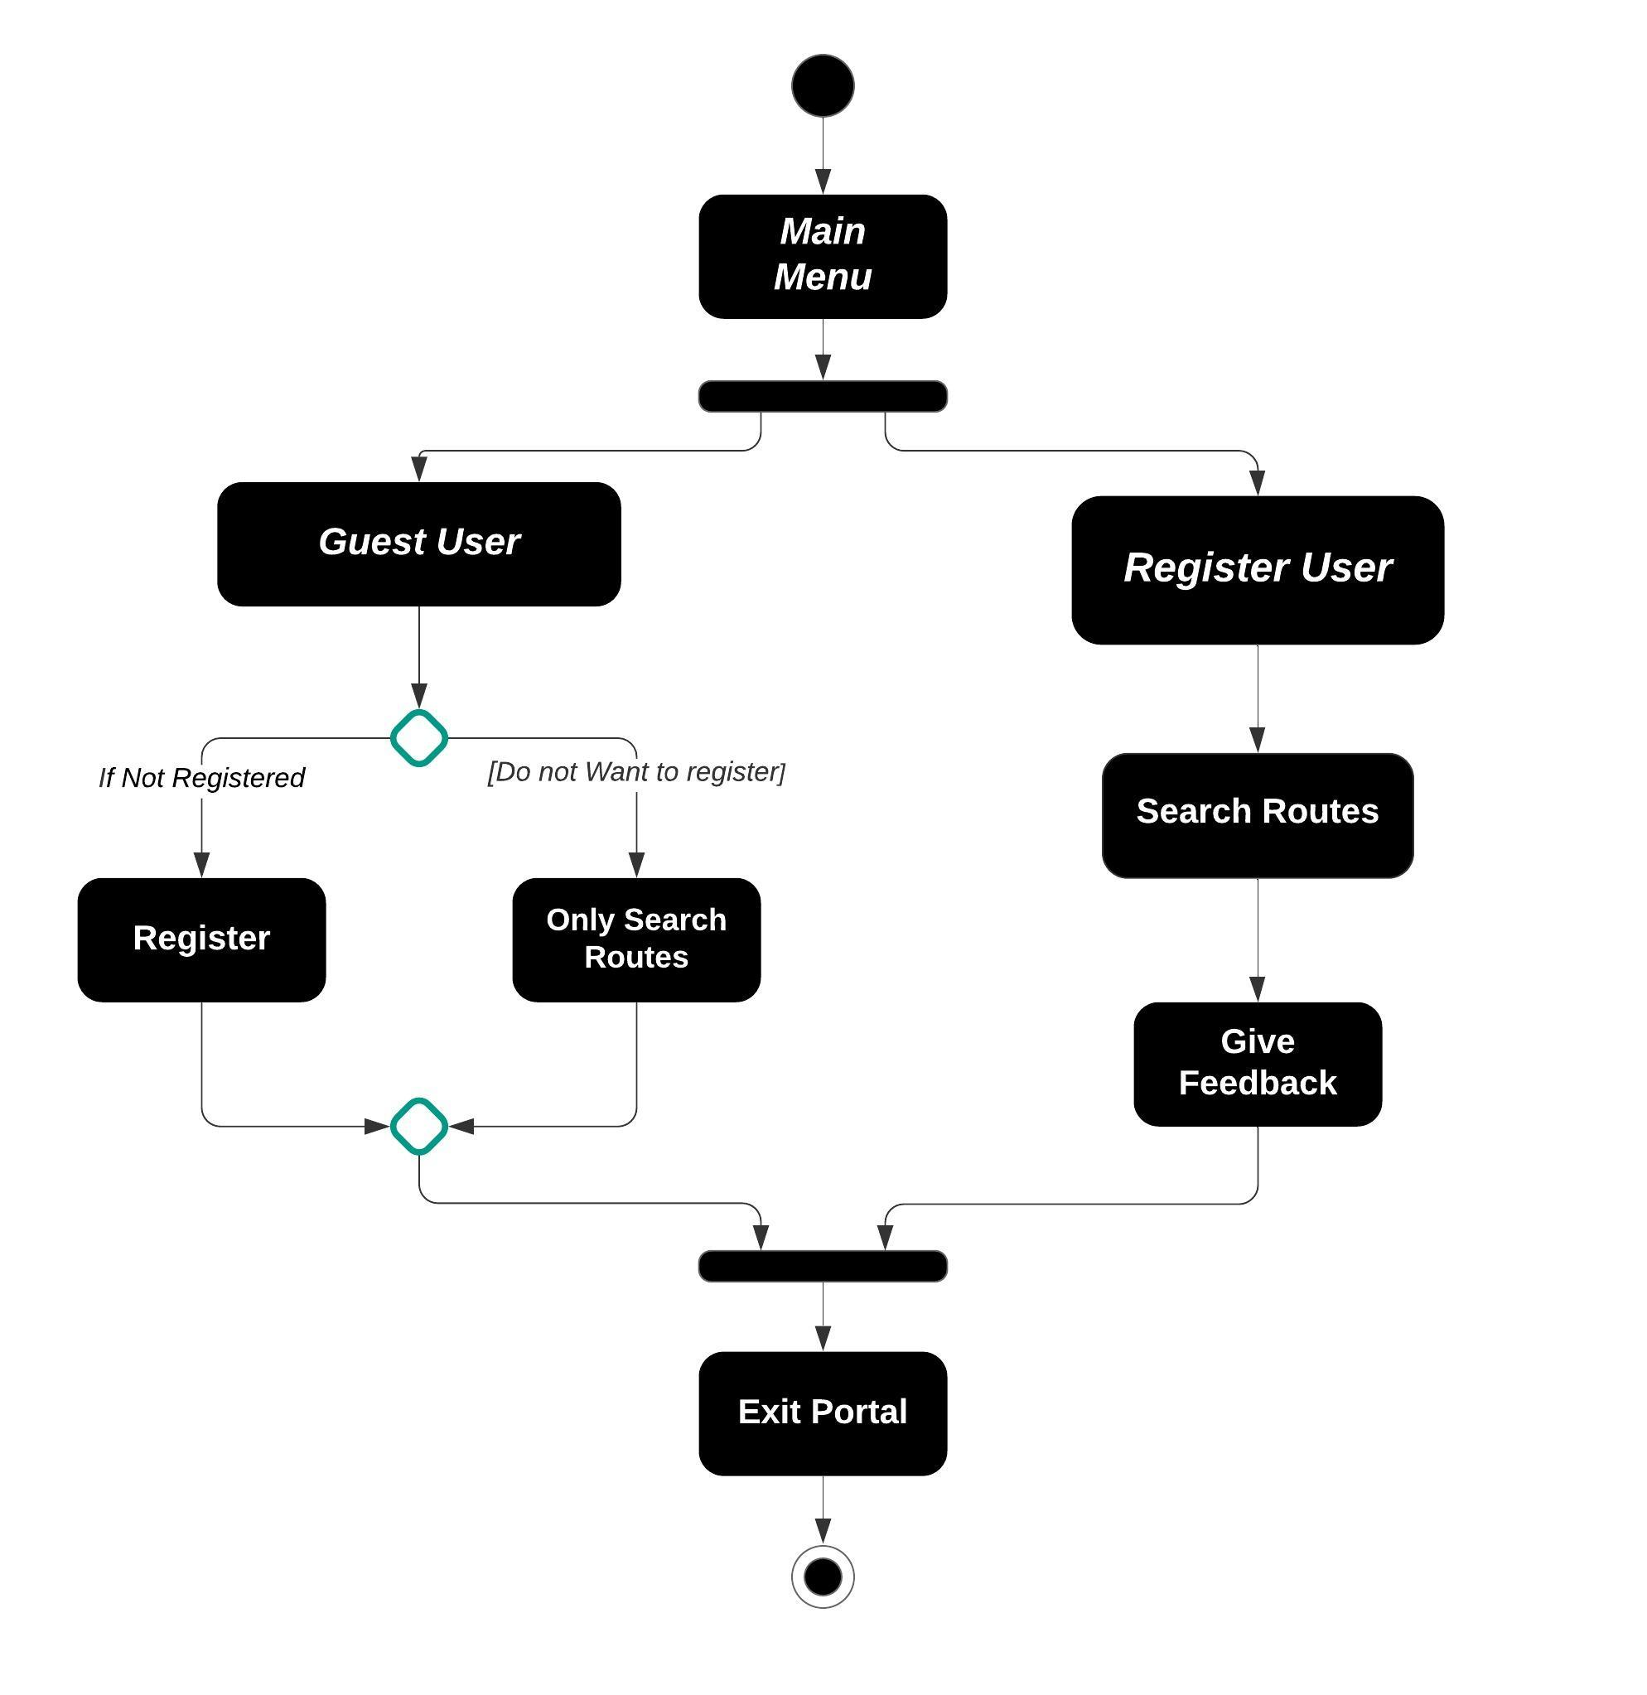**Activity - Diagram**

**Sequence -Diagram**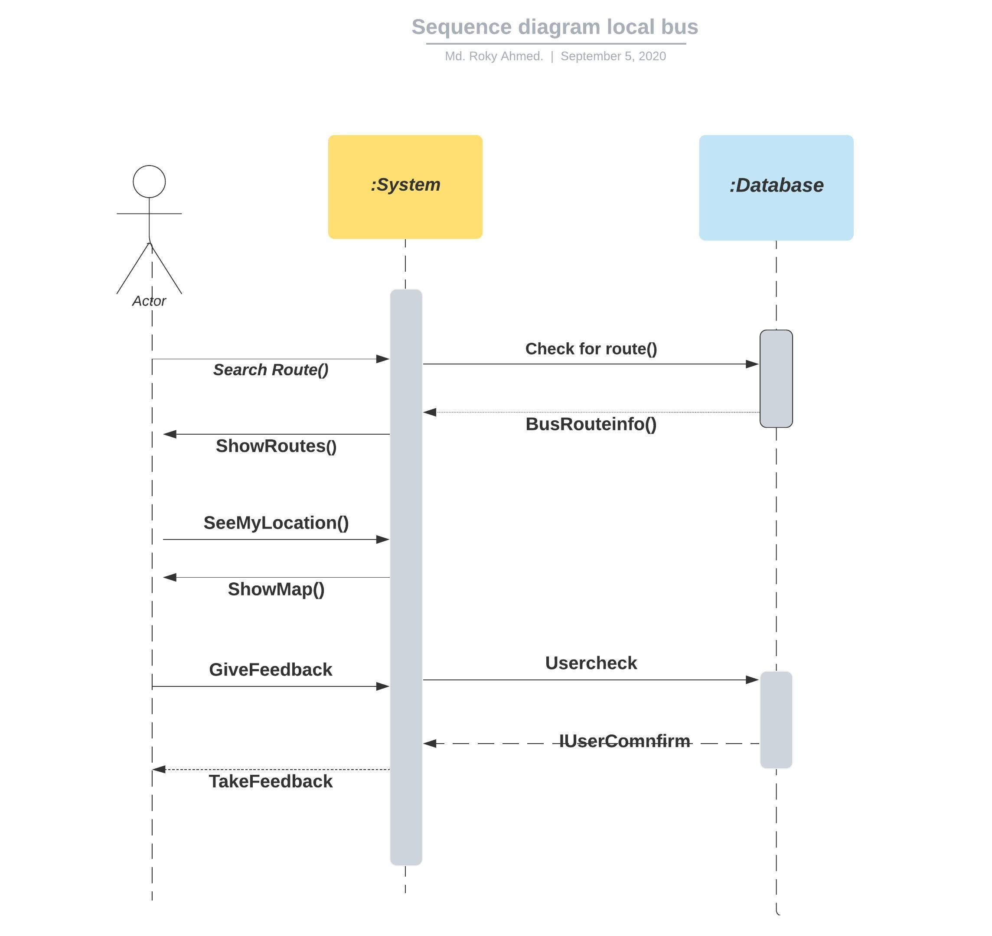ER Diagrams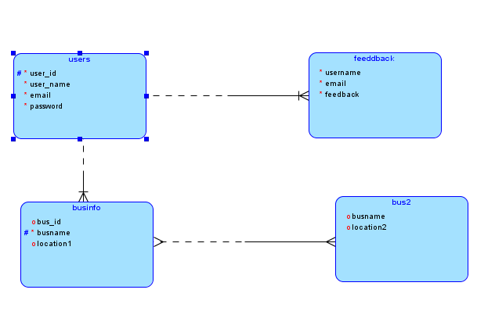Logical Model

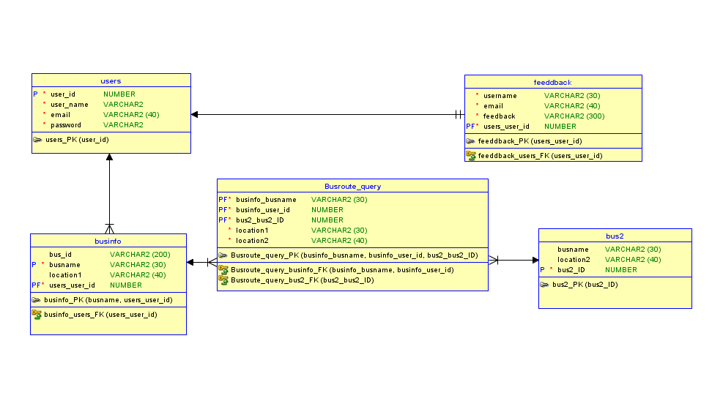Relation Model

Project Snippets

Sign-in Form

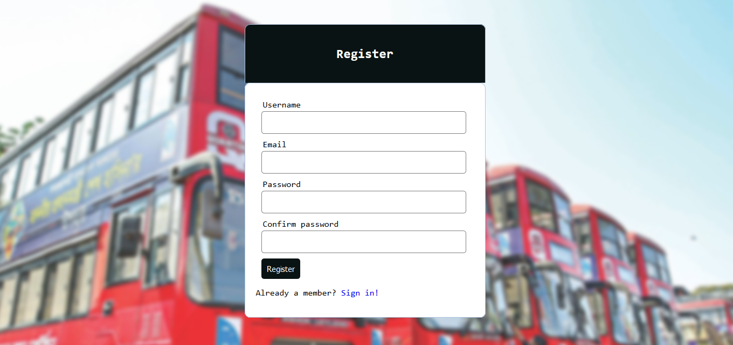

Log-in Form

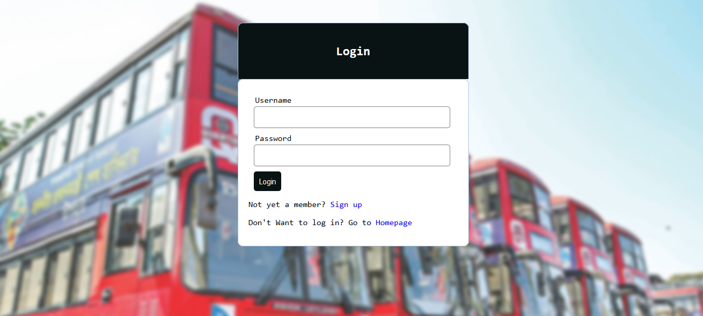

Log In session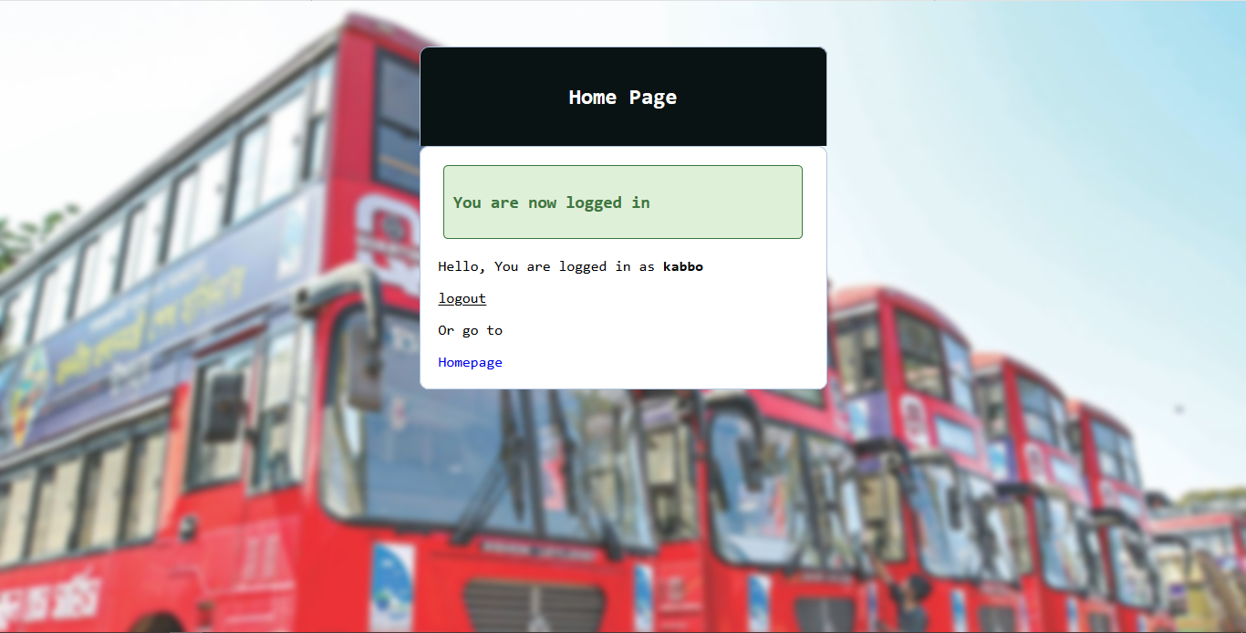

Homepage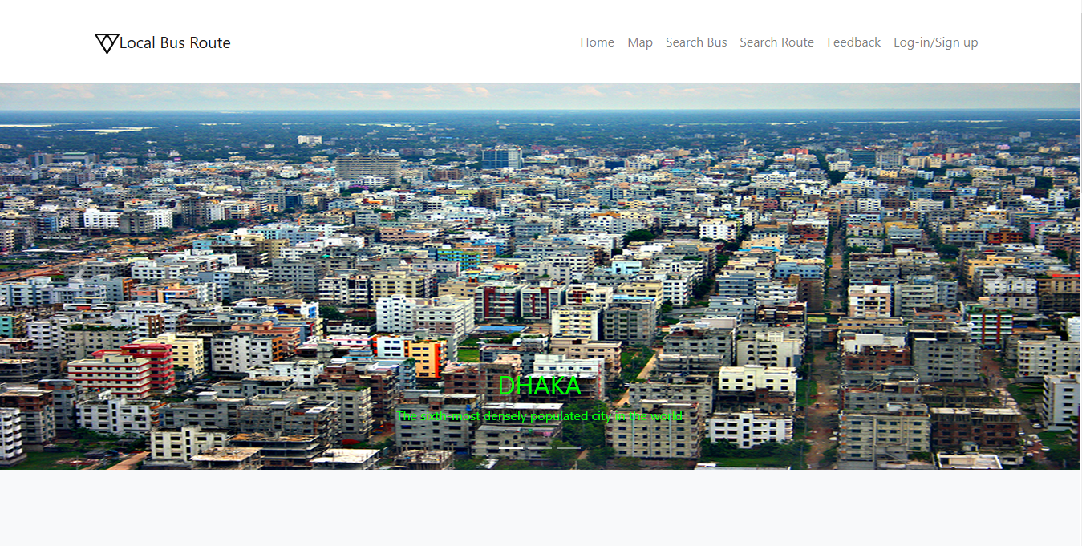

Sub-header & Portfolio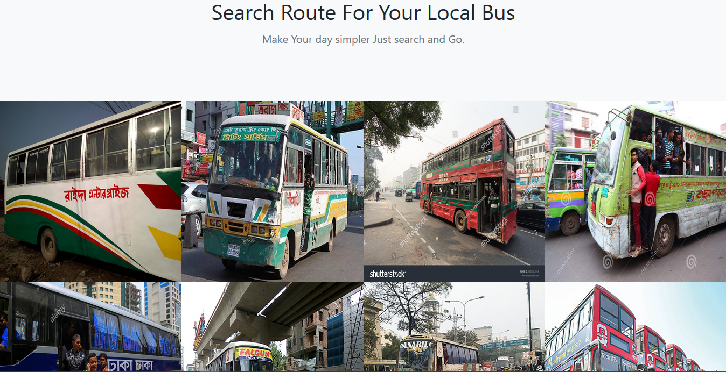

Footer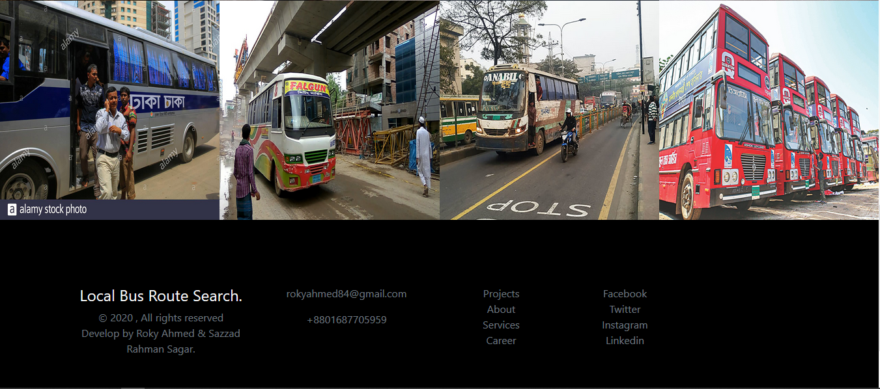

Portfolio Landing page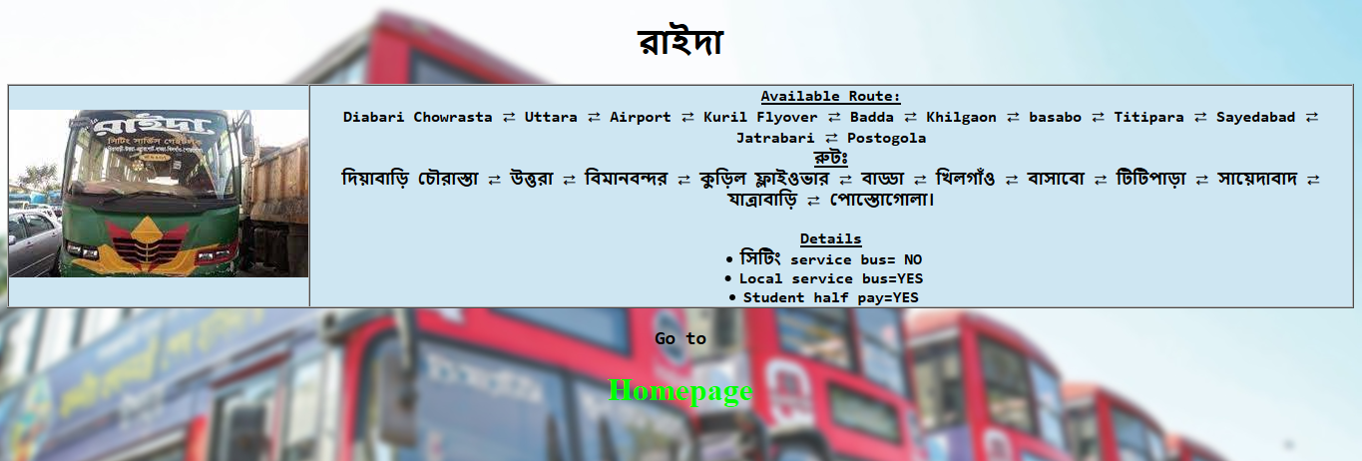

Maps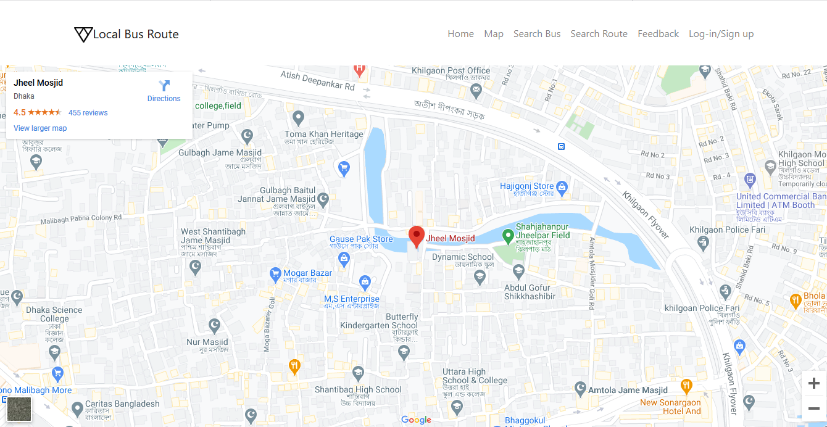

Bus Name Query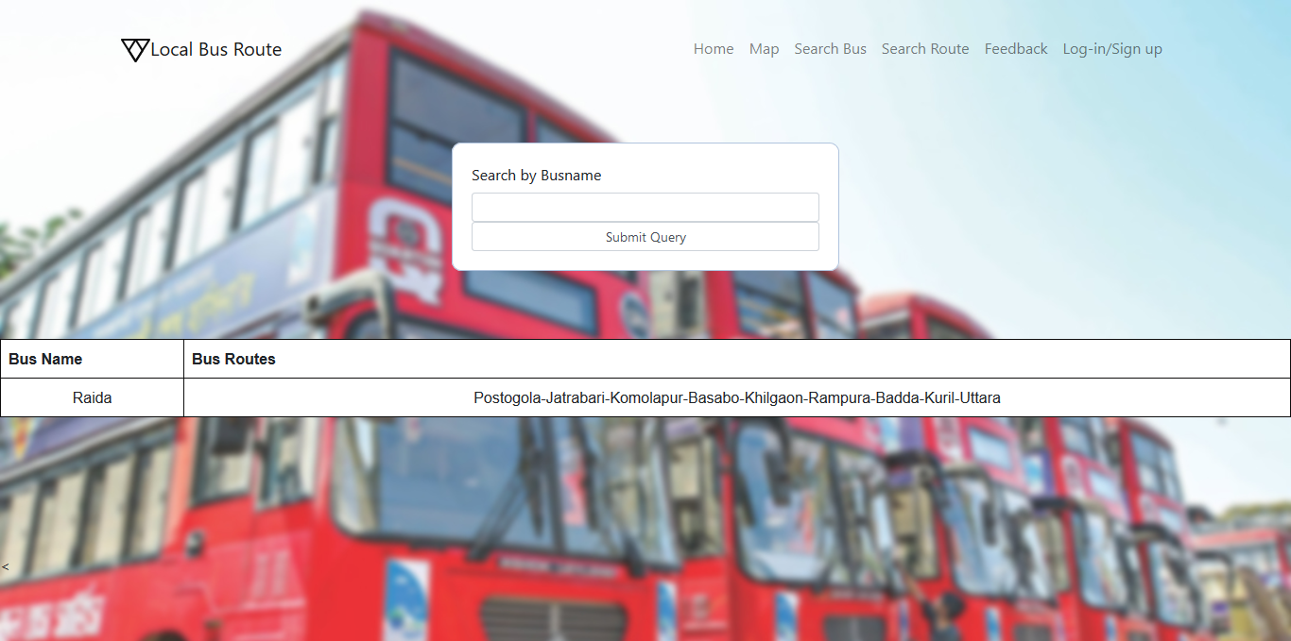

Bus Route Query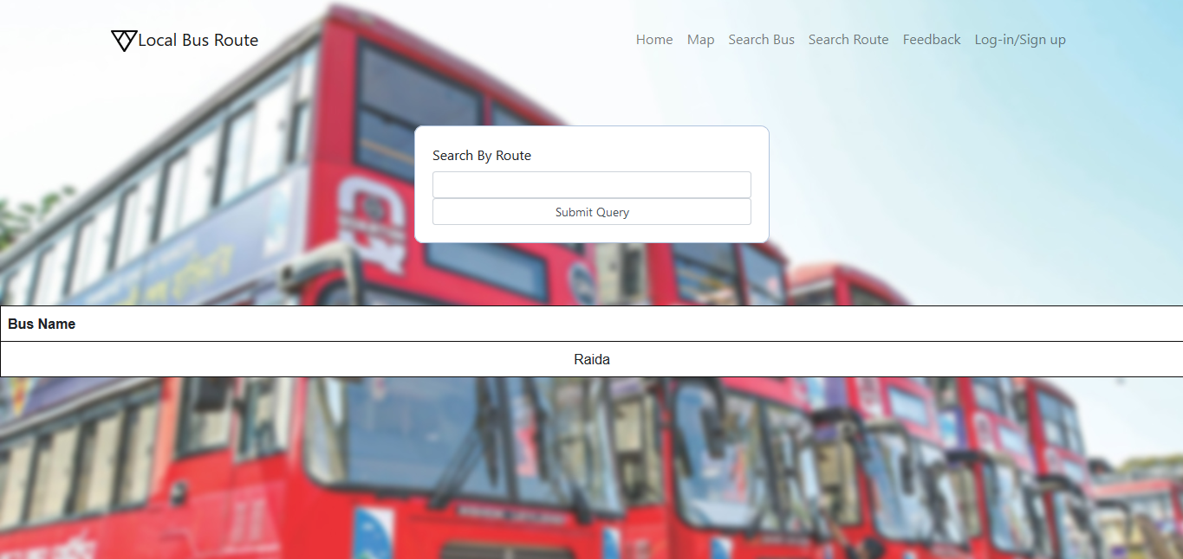

Feedback Page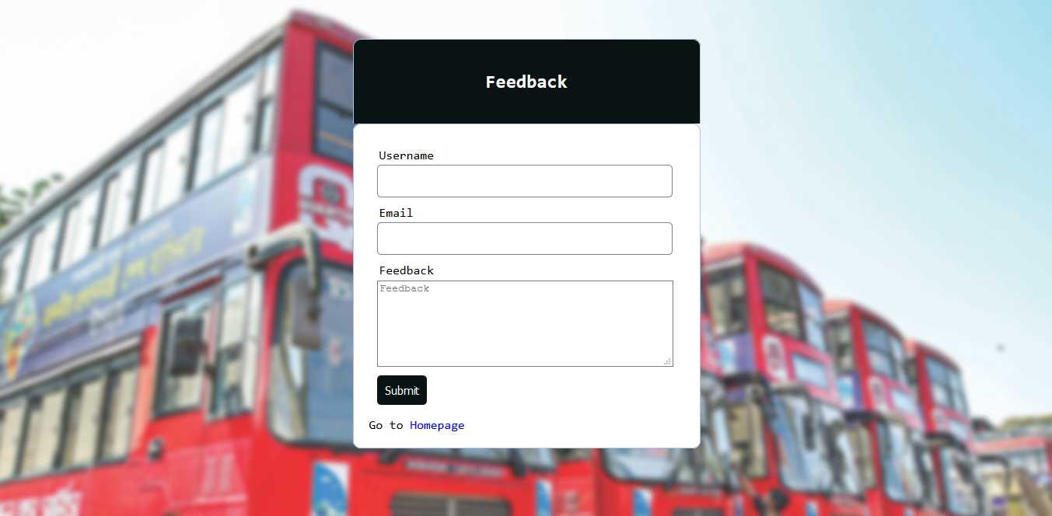

Future Plans:

• Develop an App .

• Intregate more features.

• More Interactive User Interface.

• Implement Fare option.

• Real time bus tracking.

• Suitable vehicle suggestion, Etc.